Quantum Utility Quick Guide

Contents

Overview 3

Main Features 4

Other Options 4

Suggested Future Modifications 5

Issues 5

Questions 5

Referenced Documents 6

# Overview

Quantum Utility is a command-line utility that automatically FTPs files down from the UPS server for the current day and backs them to a local AWS drive. The Windows Task Scheduler can run the executable on a daily basis.

#### QuantumView Overview

UPS generates numerous plain text files per day/per hour containing shipping information, including unique tracking numbers and variations of the SDI purchase order number. The utility searches the file for records of type E1 - Exception (packages that indicate any shipping issues), D1 -Delivery Short (basic delivery information provided a couple hours after delivery) and D2 – Delivery Long (records that provide more complete information).

Based on the provided plain-text tracking number (typically 18-characters) and variations of the purchase order id found in the ShipmentReferenceNumber (Values 1&2) and PackageReferenceNumber (values 1 &2) fields, the utility searches the SDI database for matches.

The utility then searches the PeopleSoft Purchase Order table (PS_PO_HDR) and the shipping table (PS_ISA_ASN_SHIPPED) for matches on the tracking number and/or purchase id. Once it finds a match, it updates the PS_AS_XPD_COMMENT Notes_1000 field (which is typically displayed on the table under Expedite PO. If the utility does not find a match on the tracking number or purchase order id, an alert is written to the SDIX_UPS_QUANTUMVIEW_LOG table.

When running from the command line, utility will pull down the files, parse each until it finds an E1, D1 or D2 match and then check to see if it exists in the DB. Outputs to the LOG table and console the results of the search.

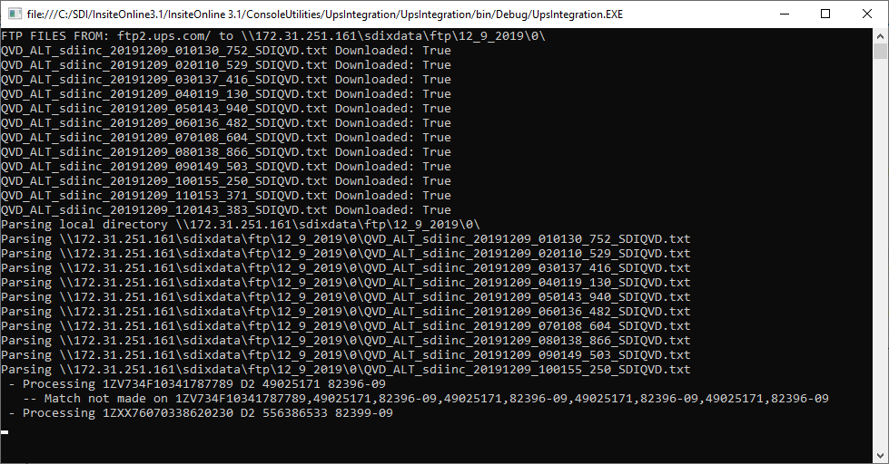

Users can run UpsIntegration.exe from \InsiteOnline3.1\InsiteOnline 3.1\ConsoleUtilities\UpsIntegration\UpsIntegration\bin\Debug. User should not separate .exe from the winscp support files -

#### When to run

As UPS updates their FTP files throughout the day, running this application at 11:45PM EST each day should retrieve all items output during the day.

#### System Debugging

The application displays the application progress on the command line for those watching in real time. However, it also writes the results of the matches (and parameters) used to the SDIX_UPS_QUANTUMVIEW_LOG. If there are any system or C# errors, the raw .Net errors are written to the SDIX_UPS_QUANTUMVIEW_ERROR table.

## Main Features

Below find key features of the application:

* Searches both SHIPPING and PURCHASE ORDER tables respectively: Because the tracking number is not always found in the shipping table, it also searches the Purchase order table on the PO table as well.
* Processes pipe-delimited and Tab-delimited files: Most of the text files on the UPS server use the pipe (|) character to separate data. However, the QVD_ALT_sdiinc_20191115_110106_627_SDIQVD.txt I received contained tab-delimited characters. It is possible a user opened it in excel and accidentally re-saved it with tabs. But, just in case, I added the tab-delimitation process, which searches for the tracking number and purchase order id using regular expression patterns.
* Handles Multiple field Arrangements: The file fields might not appear in the same order. Additionally, not all the fields will always appear in each file. Additionally, M. Randall/others can request adjusting the data included in the outputted text files. As a result, the utility does not assume each file will contain the same fields in the same order. It runs through the header of each file to identify its position. On a bonus, the field header titles never vary and always stick to camel case i.e. RecordType/ShipperNumber –
* Pulls from 4 different fields to identify purchase order: Purchase order does not always appear in the files, does not always appear in the same format or in the same fields. The SDI PO ID typically contains 10 characters. Older PO IDs were numeric. Newer ones typically start with 1-2 letters, followed by numbers. The PO Ids in the QuantumView tracker text files could appear in the ShipmentReferenceNumberValue fields (1&2) and/or the PackageReferenceNumberValue fields (1&2). Additionally the PO ID appearing in the UPS file might contain a dash(-), colon(:), pound sign(#), extra spaces or extraneous letters.   
  Sample Values contained in actual files include: TX57-00075945, PM00069193, 4507699387, PO# 8044-1114, PO 0180214017, OH41-00289460, PO L04E094949, L01E094238, N22913361-00-001 PICK  
  The utility tries the values found in all 4 fields with 1-2 different variations per field (removing special characters) to find a match.
* Sometimes POIds have 2 values in one – for the moment utility parses each out, in case they’re valid POIds
* Backs up files to AWS Server: But can also default to local drive
* Testing Multiple Database Options: As none of the earlier tracking numbers appeared in the STAR table, for testing, the utility currently checks the STAR and then the RPTG tables. And, updates the STAR database (to prevent inserting test data into RPTG). Will require DBAdmin to synch the PS_PO_HDR, PS_ISA_ASN_SHIPPED and PS_AS_XPD_COMMENT tables to STAR so that the QA tester, Mindy and key users can verify functionality.

## Other Options

The below items are options coded into the system but not

* Can pull files for a specific date. Currently, app defaults to current date. However, can activate feature to accept date at command line option
* Date specific option also warns users that files might not exist on server if date requires files 15-19 days old
* Option to email users (QuantumEmailUtility – created to handle email capabilities)
* Option exists to FTP files between specific date ranges
* Option to write log files to local directory
* Option to handle differing database connections

## Suggested Future Modifications

The following items are suggested for the future to ideally speed up queries and make data responses more immediate -

* Use Stored procedures instead of database selects
* Use Quantum API instead of FTP
* Alert if files not FTPd to local (base functionality already exists, just need to activate)

## Issues

The below items exist as potential issues in the data

* None of the tracking #s in the earlier files were found in the relevant RPTG or STAR database tables (can forward on those tracking IDs for validation) _ For instance, in \\172.31.251.161\sdixdata\ftp\12_10_2019\12_5_2019\QVD_ALT_sdiinc_20191205_010147_189_SDIQVD.txt - none of the tracking numbers were matched. It was primarily the pOIDs.
* Typically find matches more along the Poids in the PS_PO_HDR table as opposed to the tracking numbers
* UPS alternates the PO ID format. I currently update the code everytime I encounter a new variation, but that will require close watching of the LOG table and updating the code accordingly if a new pattern appears
* Redundant entries in COM table, currently the same POID might have multiple tracking numbers in the same file. That means that POID might have multiple entries in the comments table
* When there's a match on POID, but there's no corresponding line_nbr, Sched_nbr or oprid from the ship table, for insert into the COM table, use 0s for those files
* What happens when a POID exists and has multiple line_nbrs in both the COM and SHIPPING TABLES? Currently I default to using the last row, but any other suggestions?

## Questions

* Are there any other fields you might want to pull from the files?
* Sometimes POIds have 2 values in one – initially the utility did not parse them out–

0290214800/00315055042 OR 335520065171741, 8593793254 OR AS04041816 & AS04040762,S-14341 & S-14342 – Should these be handled separately?

* Testing Multiple Database Options: Will require DBAdmin to synch the PS_PO_HDR, PS_ISA_ASN_SHIPPED and PS_AS_XPD_COMMENT tables to STAR so that the QA tester, Mindy and key users can verify functionality.
* Redundant Entries*:* As the same POID might have multiple tracking numbers in the same file, POID might have multiple entries in the comments table. Should we just combine these into one row (as opposed to multiple) . For instance, POID C01G591513 had 8 unique tracking numbers in the \\172.31.251.161\sdixdata\ftp\12_10_2019\12_5_2019\QVD_ALT_sdiinc_20191205_010147_189_SDIQVD.txt
* For emailing, do you want that batched or an email sent to client immediately? Sometimes Vendor_Id contains vendor email directly, but what else can we use to identify client contact information ? Also, what are the SMTP server/smtp port and email credentials (logon/password) and what default sender email should utility use
* When there's a match on POID, but there's no corresponding line_nbr, Sched_nbr or oprid from the ship table should we use something other than 0s for entry into the com table for those corresponding fields
* What happens when a POID exists and has multiple line_nbrs in both the COM and SHIPPING TABLES? Currently I default to using the last row, but any other suggestions?
* WHAT DO I USE FOR ISA_PROBLEM_CODE IF IT IS AN INSERT? Currently, I use record type.

if run on the same day with the same parameters, the utility deletes pre-existing files - For instance, if user FTPs files for on 12092019 for 12092019 in the morning, the utility will create a 12092019/0 folder (indicating the date the files are pulled and days from the current date the and re-runs files for on 12092019 for 12092019, the utility will pull down fresh files (and delete the earlier ones from the local).

However, if users process files on 12/09/2019 but want to pull down files from 5 days ago, the utility will not delete the earlier 12092019

## Referenced Documents

* Code Documentation – See attached excel. This application contains 3 utility files for FTP, Database and string manipulations, in addition to the code
* CSV_File_guide_v8 – Jan2016.pdf For more info on the formatting of the plain text Quantum View files, please see (provided by M. Randall)
* UPS Integration 1.2 and 2.2 - For a high level, first pass requirements document please see, (provided by M. Randall V. Karthikeyan, whose team created the first pass program.cs)